**A NEW CHANNEL ESTIMATION TECHNIQUE FOR 5G MIMO COMMUNICATION SYSTEMS**

**ABSTRACT**

One of the key areas where Internet of Things (IoT) is facilitating the use of numerous transmitters on board and enabling the use of Multiple Input Multiple Output (MIMO) systems for improved communications is the health care sector. It can be difficult to use 5G MIMO systems with quality of performance (QoP) that are appropriate for IoT applications. For 5G MIMO wireless communication systems for IoT applications, a training symbol-based channel estimation approach is defined, proposed, and studied in this study. For refining the proposed channel estimator, an M-estimator is recommended. Comparing simulation results with Least Squares (LS) channel estimation with and without Discrete Fourier Transform allows for an evaluation of the suggested technique's performance (DFT).

**Keywords:** ECG Biometric, Authentication.

**CHAPTER 1**

**INTRODUCTION**

I. INTRODUCTION

Rapid growing of mobile users and exponential growing demand of higher data rates force many practical challenges on existing cellular networks and their developments to provide a high network capacity with extensive area coverage to meet customer demands of upcoming 5G networks [1]. Major disadvantage of existing networks are low data rate, minimum quality of experience (QoE), low end-to-end performance, less indoor coverage, poor mobility performance etc. Similarly, network operators face difficulties in terms of providing satisfactory services e.g., high spectral efficiency, huge network capacity, large availability of spectrum, low latency, & lower energy consumption. In order for 5G MIMO communication systems to work for both the identified demands, plans for spectral efficiency improvement, scheduling for channel information, coding and adaptive modulation are required. All these techniques need an (CSI) i.e. accurate Channel State Information available at a transmitter end. An estimation of such CSI is crucial for high data throughput .

In first algorithm is OMP i.e. orthogonal matching pursuit with lower complexity is used to identify the common support set followed by (LS) method i.e. least square for obtaining the channel estimation and it assumes perfect CSI measurement feedback from an User Equipment (UE) to Base Station (BS) which may not be possible in practice and alternate CSI measurement approaches need to be considered.

In [7], a new channel estimation technique was proposed with enhanced Kalman filter which operates to reduce the noise levels, improves the channel conditions and Quality of Service [QoS] over Wireless Communication environments.

In [8], channel estimation with minimum mean -squared-error (MMSE) criterion for orthogonal frequency division multiplexing (OFDM) systems was investigated. MMSE estimator was studied first which uses the correlation of a frequency response on different instant of time and frequency for a channel. This MMSE channel estimator may be a frequency domain filter with the help of the fast Fourier transform (FFT), and it is followed by a time -domain filters. Further, an estimator which is insensitive to a channel statistics was proposed and analyzed. A multiuser detector using M-estimator was presented in for non-Gaussian flat- fading channels.

Hence, in this paper, an M-estimator based channel estimation technique for 5G wireless communication channels is proposed and studied.

**CHAPTER 2**

**LITERATURE REVIEW**

**[1]O. E. Ijiga:** The advancement in wireless communication applications encourages the use of effective and efficient channel estimation (CE) techniques because of the varying behaviour of the Rayleigh fading channel. In most cases, the emphasis of most proposed CE schemes is to improve the CE performance and complexity for ensuring quality signal reception and improved system throughput. Candidate waveforms whose designs are based on filter bank multi-carrier (FBMC) modulation techniques such as filter bank orthogonal frequency division multiplexing based on offset quadrature amplitude modulation (OFDM-OQAM), universal filtered multicarrier (UFMC) and generalised frequency division multiplexing based on offset quadrature amplitude modulation (GFDM-OQAM) are no exception to the use of these proposed CE techniques in the literature. These schemes are considered as potential waveform candidates for the physical/media access control layer of the emerging fifth generation (5G) networks. Therefore, pinpoint CE techniques represent an important requirement for these waveforms to attain their full potentials. In this regard, this paper reviews the concept of CE as applicable to these waveforms as well as other waveform candidates under consideration in the emerging 5G networks. Since the design of the majority of the waveform candidates is filter based, a review of the general filter design considerations is presented in this paper. Secondly, we review general CE techniques for candidate waveforms of next generation networks and classify some of the studied CE techniques. In particular, we classify the CE schemes used in filter bank OFDM-OQAM and GFDM-OQAM based transceivers and present a performance comparison of some of these CE schemes. Besides, the paper reviews the performances of two linear CE schemes and three adaptive based CE schemes for two FBMC based waveform candidates assuming near perfect reconstruction (NPR) and non-perfect reconstruction (Non-PR) filter designs over slow and fast frequency selective Rayleigh fading channels. The results obtained are documented through computer simulations, where the performances of the studied CE schemes in terms of the normalised mean square error (NMSE) are analysed. Lastly, we summarise the findings of this work and suggest possible research directions in order to improve the potentials of the studied candidate waveforms over Rayleigh fading channels.

**Summary:** In this paper, This paper presents a review of the performances of CE schemes for candidate waveforms of xG wireless networks. Firstly, the design of digital filters is reviewed since the physical layer structure of these waveforms are based on filters developed from a well-designed prototype filter. In subsequent sections, the importance of CE for wireless communication networks is emphasised. As such, the CE techniques deployed for these waveforms in the literature are identified and classified, where the classification of CE schemes in application to filter and non-filter-based waveforms currently under consideration for xG networks is narrowed down.

**[2] T. Anil Kumar, Sk Nilofer and R. Sahithi :** In this paper, pilot-assisted techniques for channel estimation (CE) are simulated for Universal Filtered Multi-Carrier (UFMC) modulation scheme. UFMC aims at replacing orthogonal frequency division multiplexing (OFDM) and improves performance and robustness in the case of timefrequency misalignment. These techniques efficiently support Internet of Things (IoT) and massive machine type communications (mMTC), which are identified as challenges for 5G wireless communication systems (WCS). Pilot-aided techniques are adopted and applied to OFDM and UFMC. Simulation results are supplemented to compare the performance of UFMC systems with conventional CP-OFDM systems. Index terms:—Channel estimation; 5G; timing offset; synchronization; OFDM; UFMC.

**Summary:** In this paper, synchronization (pilot-based and cyclic prefix- based) is analyzed and investigated. From simulation results, it is observed that pilot-based synchronization method outperforms cyclic prefix- based synchronization with little addend in computational complexity. Further, channel estimation along with pilot sequences are studied and investigated for OFDM and UFMC systems. Simulation results are provided for performance comparison of OFDM and UFMC systems in flat fading channel model. These results show that better performance gains were achieved for UFMC systems for the investigated flat-fading channel model.

**[3] T. L. Marzetta,:** As A cellular base station serves a multiplicity of single-antenna terminals over the same time-frequency interval. Time-division duplex operation combined with reverse-link pilots enables the base station to estimate the reciprocal forward- and reverse-link channels. The conjugate-transpose of the channel estimates are used as a linear precoder and combiner respectively on the forward and reverse links. Propagation, unknown to both terminals and base station, comprises fast fading, log-normal shadow fading, and geometric attenuation. In the limit of an infinite number of antennas a complete multi-cellular analysis, which accounts for inter-cellular interference and the overhead and errors associated with channel-state information, yields a number of mathematically exact conclusions and points to a desirable direction towards which cellular wireless could evolve. In particular the effects of uncorrelated noise and fast fading vanish, throughput and the number of terminals are independent of the size of the cells, spectral efficiency is independent of bandwidth, and the required transmitted energy per bit vanishes. The only remaining impairment is inter-cellular interference caused by re-use of the pilot sequences in other cells (pilot contamination) which does not vanish with unlimited number of antennas.

**Summary:**The acquisition of channel state information and the phenomenon of pilot contamination impose fundamental limitations on what can be achieved with a noncooperative cellular multiuser MIMO system. Notwithstanding these limitations, we have outlined a compelling case for a time-division duplex cellular system which employs base stations equipped with large numbers of antennas that communicate simultaneously with smaller numbers of cheap, single-antenna terminals through multi-user MIMO techniques. This system has the potential to deliver high throughputs reliably on both the forward and the reverse link in fast-changing propagation environments. As the number of base station antennas grows without limit all of the effects of uncorrelated noise and fast fading disappear. What remains is inter-cellular interference that results from pilot contamination.

**[4] R. Apelfröjd:** Accurate channel state information (CSI) is important for many candidate techniques of future wireless communication systems. However, acquiring CSI can sometimes be difficult, especially if the user equipment is mobile in which case the future channel realisations must be estimated/predicted. In realistic settings the predictability of radio channels is limited due to measurement noise, limited model orders and since the fading statistics must be modelled based on a set of limited and noisy training data.

**Summary:** In this paper, this thesis, the limits of predictability for the radio channel are investigated. Results show that the predictability is limited primarily due to limitations in the training data, while the model order provides a second order limitation effect and the measurement noise comes in as a third order effect.

**[5** **R. K. Saha, P. Saengudomlert and C. Aswakul :** In this paper, an extensive review has been carried out on the trends of existing as well as proposed potential enabling technologies that are expected to shape the fifth generation (5G) mobile wireless networks. Based on the classification of the trends, we develop a 5G network architectural evolution framework that comprises three evolutionary directions, namely, (1) radio access network node and performance enabler, (2) network control programming platform, and (3) backhaul network platform and synchronization. In (1), we discuss node classification including low power nodes in emerging machine-type communications, and network capacity enablers, e.g., millimeter wave communications and massive multiple-input multiple-output. In (2), both logically distributed cell/device-centric platforms, and logically centralized conventional/wireless software defined networking control programming approaches are discussed. In (3), backhaul networks and network synchronization are discussed. A comparative analysis for each direction as well as future evolutionary directions and challenges toward 5G networks are discussed. This survey will be helpful for further research exploitations and network operators for a smooth evolution of their existing networks toward 5G networks.

**Summary**: In this paper, an extensive review has been carried out on the trends of existing as well as proposed potential enabling technologies that are expected to shape the fifth generation (5G) mobile wireless networks.

**CHAPTER 3**

**EXISTING METHOD**

This method proposed, pilot-assisted techniques for channel estimation (CE) are simulated for Universal Filtered Multi-Carrier (UFMC) modulation scheme. UFMC aims at replacing orthogonal frequency division multiplexing (OFDM) and improves performance and robustness in the case of time frequency misalignment. These techniques efficiently support Internet of Things (IoT) and massive machine type communications (mMTC), which are identified as challenges for 5G wireless communication systems (WCS). Pilot-aided techniques are adopted and applied to OFDM and UFMC. Simulation results are supplemented to compare the performance of UFMC systems with conventional CP-OFDM systems. The flow of the proposed method is shown in figure below:

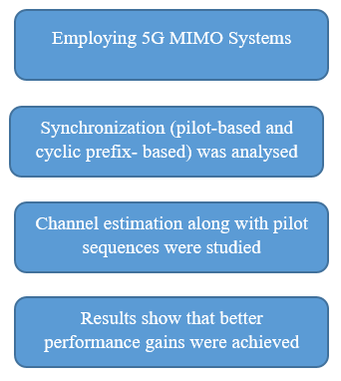

**Fig: Block Diagram of Existing Method**

**DISADVANTAGES:**

* 1 Need more parameters for the implementation.
* Requires high cost.
* Difficult to implement.

**CHAPTER 4**

**PROPOSED METHOD**

One of the method for estimation of channel is using of a training symbols and for a given N subcarriers these symbols are represented by a diagonal matrix given in eq. 1(here all the subcarriers are orthogonal to each other (i.e., no ICI)).

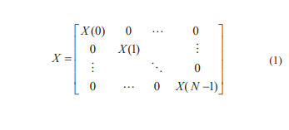

where X(k) represents a pilot tone at the kth subscriber, zero mean and V x2 gain (i.e., H[k] for each sub carrier k). In a multi-user communications, users transmit their signals using same time and frequency slots. Thus, the received signal is the superimposed signal of all transmitting users and the training signal on receiver side, Y[k], is expressed by

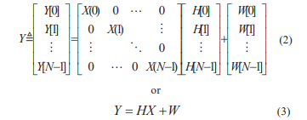

where channel vector H is expressed as H [ H [0], H [1], , H [ N 1]]T and W i.e. noise vector with zero mean and V w2 variance is expressed by W [W[0],W[1], ,W[N 1]]T .

In LS method the following equation is used for channel estimation

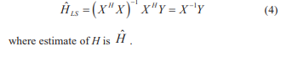

A new method M-estimator [2] is proposed for robustifying training symbol based channel estimation for 5G wireless communications. Proposed estimator penalty and influence functions are given in eq. (4), eq. (5) & eq. (6) respectively (shown in Fig.1)

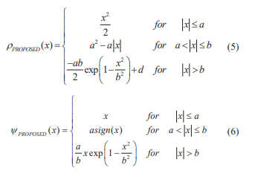

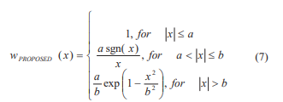

where a and b are constants and x is any datum. From an influence function, robustness measures are derived and will fix the selection constants of a= (kv2) and b = (2 kv2) , where k is any constant .M-estimator reduce the outcome of outliers, resulting min

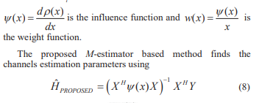

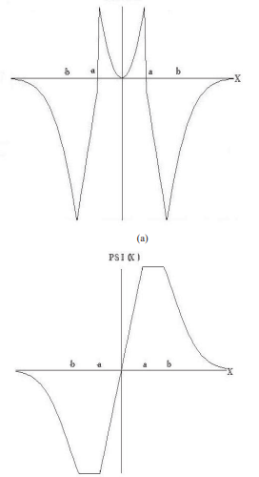

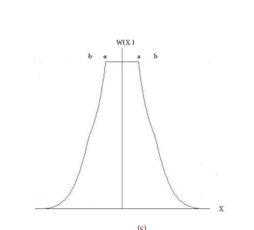

Figure 1. (a) Penalty function, (b) influence function, and

(c) weight functions of the proposed M-estimator

**CHAPTER 5**

**ADVANTAGES AND APPLICATIONS**

**Advantages:**

1. Gives the better results of channel estimation.

2. Less complex than the Least Squares (LS) Method.

**Applications:**

* There are numerous applications for the use of Biometric Technology, but the most common ones are as follows:
* 5G MIMO
* 5G MISO
* Channel Estimations

**CHAPTER 6**

**7.1 INTRODUCTION TO MATLAB**

**What Is MATLAB?**

MATLAB is an elite dialect for specialized registering. It incorporates calculation, representation, and programming in an easy to-utilize condition wherein issues and preparations are communicated in herbal numerical documentation. Run of the mill utilizes comprise

• Math and calculation

• Algorithm advancement

• Data obtaining

• Modeling, re-enactment, and prototyping

• Data examination, investigation, and representation

• Scientific and designing illustrations

• Application advancement, including graphical UI building

MATLAB is an intuitive framework whose important statistics aspect is an show off that does not require dimensioning. This allows you to tackle several specialized processing issues, particularly those with framework and vector info, in a small quantity of the time it'd take to compose a program in a scalar non intuitive dialect, as an instance, C or FORTRAN.

The call MATLAB stays for grid studies facility. MATLAB changed into first of all composed to present easy access to framework programming created by way of the LINPACK and EISPACK ventures. Today, MATLAB motors fuse the LAPACK and BLAS libraries, inserting the cutting side in programming for network calculation.

MATLAB has advanced over a time of years with contribution from several customers. In university situations, it's far the usual academic apparatus for early on and propelled guides in mathematics, designing, and science. In enterprise, MATLAB is the tool of choice for excessive-profitability studies, advancement, and exam.

MATLAB highlights a collection of more utility-specific arrangements known as tool booths. Important to most clients of MATLAB, device kits permit you to learnandapply particular innovation. Tool compartments are exhaustive accumulations of MATLAB capacities (M-records) that reach out the MATLAB condition to take care of precise training of problems. Territories in which tool stash are reachable include flag coping with, manipulate frameworks, neural structures, fluffy reason, wavelets, pastime, and severa others.

**The MATLAB System:**

The MATLAB system consists of five main parts.

**Development Environment:**

 This is the set of tools and centres that help you operate MATLAB features and files. Many of that gear are graphical person interfaces. It includes the MATLAB desktop and Command Window, a command history, an editor and debugger, and browsers for viewing assist, the workspace, files, and the hunt direction.

**The MATLAB Mathematical Function:**

This is a great collection of computational algorithms ranging from standard capabilities like sum, sine, cosine, and complex arithmetic, to extra sophisticated features like matrix inverse, matrix eigen values, Bessel functions, and speedy Fourier transforms.

**The MATLAB Language:**

This is a high-level matrix/array language with control flow statements, functions, data structures, input/output, and object-oriented programming features. It allows both "programming in the small" to rapidly create quick and dirty throw-away programs, and "programming in the large" to create complete large and complex application programs.

**Graphics:**

MATLAB has considerable centres for displaying vectors and matrices as graphs, as well as annotating and printing those graphs. It consists of high-stage functions for 2-dimensional and 3-dimensional records visualization, photograph processing, animation, and presentation graphics. It also consists of low-stage capabilities that will let you absolutely customise the appearance of graphics as well as to construct complete graphical person interfaces for your MATLAB programs.

**The MATLAB Application Program Interface (API):**

This is a library that allows you to put in writing C and Fortran applications that have interaction with MATLAB. It consists of facilities for calling workouts from MATLAB (dynamic linking), calling MATLAB as a computational engine, and for studying and writing MAT-documents.

**7.2 MATLAB WORKING ENVIRONMENT:**

## MATLAB DESKTOP:

Matlab Desktop is the principle Matlab application window. The desktop consists of five sub windows, the summon window, the workspace program, the existing catalog window, the order records window, and at the least one figure home windows, which can be proven simply while the consumer suggests a sensible.

The order window is the area the customer sorts MATLAB orders and expressions at the initiate (>>) and wherein the yield of these fees is shown. MATLAB characterizes the workspace because the association of factors that the customer makes in a work session. The workspace software demonstrates these elements and some statistics approximately them. Double tapping on a variable within the workspace application dispatches the Array Editor, which may be applied to get data and salary instances modify sure homes of the variable.

The present Directory tab over the workspace tab demonstrates the substance of the existing registry, whose way is seemed within the present index window. 1For case, within the windows running framework the manner may be as consistent with the subsequent: C:MATLABWork, demonstrating that registry "paintings" is a subdirectory of the primary catalog "MATLAB", which is delivered in pressure C. Tapping on the bolt inside the present index window demonstrates a rundown of as of past due utilized approaches. Tapping at the seize to one aspect of the window enables the client to exchange the existing catalog.

MATLAB utilizes an inquiry way to discover M-data and different MATLAB related documents, which might be sort out in catalogs within the PC file framework. Any file keep strolling in MATLAB must dwell inside the ebb and go with the flow registry or in an index that is on are trying to find manner. Of direction, the statistics supplied with MATLAB and math works device kits are included into the inquiry way. The least stressful method to look which indexes are at the inquiry manner. The handiest method to peer which catalogs are soon the quest way, or to encompass or regulate an inquiry manner, is to pick set manner from the File menu the computer, and after that utilization the set way exchange container. It is exquisite exercise to add any typically utilized catalogs to the pursuit way to hold a strategic distance from again and again having the exchange the existing index.

The Command History Window contains a record of the orders a client has entered in the charge window, including both present and past MATLAB sessions. Already entered MATLAB orders can be chosen and re-executed from the charge history window by right

tapping on a summon or arrangement of orders. This activity dispatches a menu from which to choose different choices notwithstanding executing the orders. This is helpful to choose different choices notwithstanding executing the summons. This is a valuable component while trying different things with different orders in a work session

**Using the MATLAB Editor to create M-Files:**

The MATLAB manager is both a word processor unique for making M-statistics and a graphical MATLAB debugger. The proofreader can display up in a window without everybody else, or it could be a sub window in the laptop. M-facts are intended by means of the expansion .M, as in pixelup.M. The MATLAB editorial manager window has various draw down menus for errands, for instance, sparing, seeing, and troubleshooting documents. Since it plays out a few basic checks and furthermore utilizes shading to separate between exclusive additives of code, this content device is suggested as the equipment of selection for composing and changing M-capacities. To open the proofreader, sort regulate at the incite opens the M-report filename.M in a supervisor window, organized for altering. As referred to before, the record has to be inside the momentum catalog, or in an index within the pursuit manner.

**Getting Help:**

The important technique to get help on line is to utilize the MATLAB assist application, opened as a exclusive window both via tapping at the query mark image at the computing device toolbar, or by using writing help program on the provoke within the order window. The help Browser is an internet application coordinated into the MATLAB computing device that shows a Hypertext Markup Language (HTML) statistics. The Help Browser contains of two sheets, the assistance pilot sheet, used to find out data, and the show sheet, used to look the statistics. Clear as crystal tabs aside from pilot sheet are applied to play out a pursuit. Second, within the motion pictures taken via transferring camera setup, the state of affairs becomes extra complex because the heritage may additionally exchange by using shifting shot, we cannot tune item motion exactly inside the sum of distinction map. Therefore, in this situation, the purpose is executed through reusing the previous seam and applying it to the cutting-edge body. In order to discover the seams, we use the preceding seam from previous body to look the modern-day seam in contemporary frame. our method is using a seam computed in frame1 (in crimson) to go looking a comparable seam in frame2. For the pixels close by the area of previous seam, we decide how a lot the selected pixel might vary from the pixel of preceding seam. We use difference of the 2 pixels as the degree of temporal coherence. If the distinction value of first seam pixel is over the threshold, we can keep to go looking the next seam pixel on three feasible pixels (in yellow, blue and brown) in subsequent row, until we discover 5 consecutive pixels that also exceed the threshold.

When we can't search the matching seam, we recalculate the energy for a new seam. We assume a seam 𝑆l-1 has been calculated inside the previous body, and a seam must be calculated for the contemporary frame. For preserving the temporal coherence, we want to make a new seam close to the previous seam with the identical index. We use the distinction among preceding seam and all pixels at the current body as the measure

Thus we upload temporal coherence price Tc(i,j) to the strength map earlier than calculating a seam 𝑆L. The price Tc is zero while the body pixels have the equal fee as previous seam pixels. Using our temporal coherence price, we will calculate the seam which has least electricity and is more close to the preceding seam in previous frame. Consequently, we will decrease the jittery artifacts inside the films.

**COMMUNICATION:**

Communications System Toolbox™ offers algorithms and gear for the layout, simulation, and analysis of communications systems. These capabilities are furnished as MATLAB ® features, MATLAB System gadgets™, and Simulink ® blocks. The machine toolbox includes algorithms for source coding, channel coding, interleaving, modulation, equalization, synchronization, and channel modeling. Tools are supplied for bit blunders charge evaluation, producing eye and constellation diagrams, and visualizing channel characteristics. The machine toolbox additionally provides adaptive algorithms that allow you to version dynamic communications structures that use OFDM, OFDMA, and MIMO techniques. Algorithms support fixed-point facts arithmetic and C or HDL code era.

**Key Features**

▪ Algorithms for designing the physical layer of communications systems, which includes supply coding, channel coding, interleaving, modulation, channel fashions, MIMO, equalization, and synchronization

▪ GPU-enabled System objects for computationally intensive algorithms together with Turbo, LDPC, and Viterbi decoders

▪ Interactive visualization equipment, consisting of eye diagrams, constellations, and channel scattering capabilities

▪ Graphical tool for evaluating the simulated bit mistakes rate of a machine with analytical outcomes

▪ Channel models, consisting of AWGN, Multipath Rayleigh Fading, Rician Fading, MIMO Multipath Fading, and

LTE MIMO Multipath Fading

▪ Basic RF impairments, along with nonlinearity, section noise, thermal noise, and section and frequency offsets

▪ Algorithms available as MATLAB features, MATLAB System objects, and Simulink blocks

▪ Support for fixed-point modeling and C and HDL code technology

**System Design, Characterization, and Visualization:**

The layout and simulation of a communications gadget requires analyzing its reaction to the noise and interference inherent in real-world environments, reading its behavior the usage of graphical and quantitative manner, and determining whether the resulting overall performance meets requirements of acceptability. Communications System Toolbox implements a selection of obligations for communications machine layout and simulation. Many of the functions, System objects™, and blocks inside the device toolbox perform computations associated with a specific thing of a communications gadget, consisting of a demodulator or equalizer. Other talents are designed for visualization or evaluation.

**System Characterization**

The system toolbox offers several standard methods for quantitatively characterizing system performance:

▪ Bit error rate (BER) computations

▪ Adjacent channel power ratio (ACPR) measurements

▪ Error vector magnitude (EVM) measurements

▪ Modulation error ratio (MER) measurements

Because BER computations are fundamental to the characterization of any communications system, the system toolbox provides the following tools and capabilities for configuring BER test scenarios and accelerating BER simulations:

**BER tool**— A graphical user interface that enables you to analyze BER performance of communications systems. You can analyze performance via a simulation-based, semi analytic, or theoretical approach.

**Error Rate Test Console** — A MATLAB object that runs simulations for communications systems to measure error rate performance. It supports user-specified test points and generation of parametric performance plots and surfaces. Accelerated performance can be realized when running on a multi core computing platform.

**Multi core and GPU acceleration** — A capability provided by Parallel Computing Toolbox™ that enables you to accelerate simulation performance using multi core and GPU hardware within your computer.

**Distributed computing and cloud computing support** — Capabilities provided by Parallel Computing Toolbox and MATLAB Distributed Computing Server™ that enable you to leverage the computing power of your server farms and the Amazon EC2 Web service. Performance Visualization. The system toolbox provides the following capabilities for visualizing system performance:

**Channel visualization tool** — For visualizing the characteristics of a fading channel

**Eye diagrams and signal constellation scatter plots** — for a qualitative, visual understanding of system behavior that enables you to make initial design decisions

**Signal trajectory plots** — for a continuous picture of the signal’s trajectory between decision points

**BER plots** — for visualizing quantitative BER performance of a design candidate, parameterized by metrics such as SNR and fixed-point word size

**Analog and Digital Modulation**

Analog and digital modulation strategies encode the facts circulation into a sign this is appropriate for transmission. Communications System Toolbox presents some of modulation and corresponding demodulation abilities. These talents are available as MATLAB features and gadgets, MATLAB System Modulation sorts provided by the toolbox are:

**Analog,** including AM, FM, PM, SSB, and DSBSC

**Digital,** including FSK, PSK, BPSK, DPSK, OQPSK, MSK, PAM, QAM, and TCM

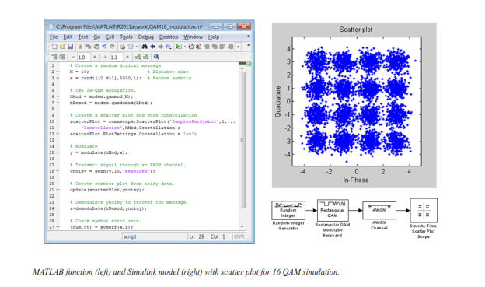

**Source and Channel Coding**

Communications System Toolbox affords source and channel coding talents that can help you develop and compare communications architectures fast, enabling you to discover what-if eventualities and avoid the need to create coding competencies from scratch.

**Source Coding**

Source coding, also referred to as quantization or signal formatting, is a manner of processing facts a good way to lessen redundancy or prepare it for later processing. The system toolbox offers a diffusion of styles of algorithms for imposing source coding and interpreting, inclusive of:

▪ Quantizing

▪ Companding (*µ*-law and A-law)

▪ Differential pulse code modulation (DPCM)

▪ Huffman coding

▪ Arithmetic coding

**Channel Coding**

▪ orthogonal area-time block code (OSTBC) (encoder and decoder for MIMO channels)

▪ Turbo encoder and decoder examples

The gadget toolbox offers application functions for developing your personal channel coding. You can create generator polynomials and coefficients and syndrome deciphering tables, in addition to product parity-take a look at and generator matrices.

The system toolbox additionally presents block and convolutional interleaving and deinters leaving functions to reduce facts errors as a result of burst mistakes in a conversation machine:

**Block,** including General block interleaver, algebraic interleaver, helical scan interleaver, matrix interleaver, and random interleaver.

**Convolutional,** including General multiplexed interleaver, convolutional interleaver, and helical interleaver

**Channel Modeling and RF Impairments**

Channel Modeling

Communications System Toolbox provides algorithms and tools for modeling noise, fading, interference, and different distortions which might be commonly found in communications channels. The system toolbox supports the subsequent styles of channels:

▪ Additive white Gaussian noise (AWGN)

▪ Multiple-enter multiple-output (MIMO) fading

▪ Single-enter single-output (SISO), Rayleigh, and Rician fading

▪ Binary symmetric

A MATLAB channel object provides a concise, configurable implementation of channel models, enabling you to

specify parameters such as:

▪ Path delays

▪ Average path gains

▪ Maximum Doppler shifts

▪ K-Factor for Rician fading channels

▪ Doppler spectrum parameters

For MIMO systems, the MATLAB MIMO channel object expands these parameters to also include:

▪ Number of transmit antennas (up to 8)

▪ Number of receive antennas (up to 8)

▪ Transmit correlation matrix

▪ Receive correlation matrix

To combat the effects noise and channel corruption, the system toolbox provides block and convolutional coding and decoding techniques to implement error detection and correction. For simple error detection with no inherent correction, a cyclic redundancy check capability is also available. Channel coding capabilities provided by the system toolbox include:

▪ BCH encoder and decoder

▪ Reed-Solomon encoder and decoder

▪ LDPC encoder and decoder

▪ Convolutional encoder and Viterbi decoder

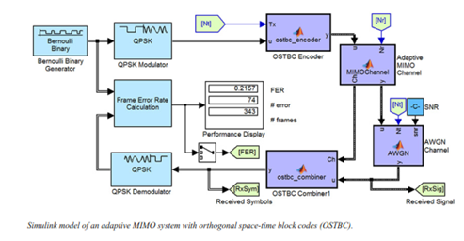

**RF Impairments**

To model the effects of a non-ideal RF front end, you can introduce the following impairments into your communications system, enabling you to explore and characterize performance with real-world effects:

▪ Memory less nonlinearity

▪ Phase and frequency offset

▪ Phase noise

▪ Thermal noise

You can include more complex RF impairments and RF circuit models in your design using SimRF™.

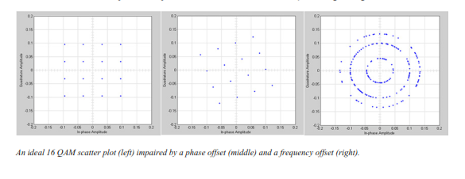

**Equalization and Synchronization**

Communications System Toolbox lets you discover equalization and synchronization strategies. These techniques are usually adaptive in nature and tough to design and symbolize. The machine toolbox affords algorithms and tools that will let you swiftly select the proper approach on your communications machine. Equalization To compare one-of-a-kind techniques to equalization, the device toolbox offers you with adaptive algorithms which include:

▪ LMS

▪ Normalized LMS

▪ Variable step LMS

▪ Signed LMS

▪ MLSE (Viterbi)

▪ RLS

▪ CMA

These adaptive equalizers are available as nonlinear decision feedback equalizer (DFE) implementations and as

Linear (symbol or fractionally spaced) equalizer implementations.

**Synchronization**

The device toolbox provides algorithms for each service segment synchronization and timing phase synchronization. For timing section synchronization, the machine toolbox presents a MATLAB Timing Phase Synchronizer object that offers the following implementation techniques:

▪ Early-late gate timing method

▪ Gardner’s method

▪ Fourth-order nonlinearity method

**Stream Processing in MATLAB and Simulink**

Most verbal exchange structures cope with streaming and frame-primarily based statistics using a aggregate of temporal processing and simultaneous multi frequency and multichannel processing. This form of streaming multidimensional processing can be visible in superior communication architectures consisting of OFDM and MIMO. Communications System Toolbox enables the simulation of advanced communications structures via helping move processing and frame-based simulation in MATLAB and Simulink. In MATLAB, circulate processing is enabled by way of System items™, which use MATLAB objects to symbolize time-based and facts-driven algorithms, sources, and sinks. System objects implicitly manipulate many information of flow processing, including information indexing, buffering, and management of set of rules state. You can mix System gadgets with fashionable MATLAB functions and operators. Most System items have a corresponding Simulink block with the identical abilities. Simulink handles circulation processing implicitly with the aid of coping with the float of information thru the blocks that make up a Simulink model. Simulink is an interactive graphical environment for modeling and simulating dynamic systems that uses hierarchical diagrams to symbolize a machine version. It includes a library of widespread-reason, predefined blocks to represent algorithms, resources, sinks, and device hierarchy.

**Implementing a Communications System**

Fixed-Point Modeling Many communications systems use hardware that requires a fixed-point representation of your design.

Communications System Toolbox supports fixed-point modeling in all relevant blocks and System objects™ with tools that help you configure fixed-point attributes.

Fixed-point support in the system toolbox includes:

▪ Word sizes from 1 to 128 bits

▪ Arbitrary binary-point placement

▪ Overflow handling methods (wrap or saturation)

▪ Rounding methods: ceiling, convergent, floor, nearest, round, simplest, and zero

Fixed-Point Tool in Simulink Fixed Point™ facilitates the conversion of floating-point data types to fixed point. For configuration of fixed-point properties, the tool tracks overflows and maxima and minima.

**Code Generation**

Once you've got advanced your set of rules or communications device, you can robotically generate C code from it for verification, rapid prototyping, and implementation. Most System gadgets, functions, and blocks in Communications System Toolbox can generate ANSI/ISO C code the use of MATLAB Coder™, Simulink Coder™, or Embedded Coder™. A subset of System gadgets and Simulink blocks also can generate HDL code. To leverage present highbrow belongings, you can choose optimizations for specific processor architectures and integrate legacy C code with the generated code.

You can also generate C code for both floating-point and fixed-point data types.

DSP Proto typing DSPs are used in communication system implementation for verification, rapid prototyping, or final hardware implementation. Using the processor-in-the-loop (PIL) simulation capability found in Embedded Coder, you can verify generated source code and compiled code by running your algorithm’s implementation code on a target processor. FPGA Prototyping

FPGAs are used in communication systems for implementing high-speed signal processing algorithms. Using the FPGA-in-the-loop (FIL) capability found in HDL Verifier™, you can test RTL code in real hardware for any existing HDL code, either manually written or automatically generated HDL code.

**CHAPTER -7**

**HARDWARE & SOFTWARE REQUIREMENTS:**

**Software:**

• Matlab R2018a.

**Hardware:**

**Operating Systems:**

• Windows 10

• Windows 7 Service Pack 1

• Windows Server 2019

• Windows Server 2016

**Processors:**

Minimum: Any Intel or AMD x86-64 processor

Recommended: Any Intel or AMD x86-64 processor with four logical cores and AVX2 instruction set support

**Disk:**

Minimum: 2.9 GB of HDD space for MATLAB only, 5-8 GB for a typical installation

Recommended: An SSD is recommended a full installation of all Math Works products may take up to 29 GB of disk space

**RAM:**

Minimum: 4 GB

Recommended: 8

**CHAPTER 9**

**CONCLUSION**

Robust training symbol based channel estimation for 5G wireless communication systems using M-estimation is proposed and studied in this paper. An M-estimator is proposed and used for optimizing the channel estimation technique. Simulation results are also provided to support efficacy of the proposed study of channel estimation in 5G wireless communication systems with additive white Gaussian noise. From simulation results, it is concluded that the proposed technique closely approximates true channel estimation for 5G MIMO wireless communication system with and without DFT.

**CHAPTER 11**

**REFERENCES**

[1] O. E. Ijiga, “Review of channel estimation for candidate waveforms of next generation networks,” J. Electronics, Vol. 8, pp. 1-50, 2019

[2]T. Anil Kumar, Sk Nilofer and R. Sahithi, “Channel estimation techniques for OFDM and UFMC systems for 5G communications,” IJRTE, vol. 8, pp. 1776-1778, 2019.

[3]T. L. Marzetta, “Noncooperative cellular wireless with unlimited number of base station antennas,” IEEE Transactions on Wireless Comm., vol. 9, no. 11, pp. 3590-3600, 2010.

[4]R. Apelfröjd, “Channel estimation and prediction for 5G applications,” PhD Dissertation, 2018.

[5]R. K. Saha, P. Saengudomlert and C. Aswakul, “Evolution toward 5G mobile networks – A survey on enabling technologies,” Engineering Journal, vol. 20, 2015.

[6]Imran Khan et.al., “A robust channel estimation scheme for 5G massive MIMO systems,” J. Wireless Communications and Mobile Computing, pp.1-8, 2019.

[7]G. Rajender, T. Anil Kumar and K. Srinivasa Rao, “Empirical Analysis of Channel Estimation Procedures with Enhanced Kalman Filter Algorithm over MIMO-OFDM Environment,” IJPAM, vol. 118, No. 19, 2018.

[8]Y. Li, L. J. Cimini and N.R. Sollenberger, “Robust channel estimation for OFDM systems with rapid dispersive fading channels,” IEEE Trans. Comm., vol. 46, pp. 902-915, 1998.

[9]F. R. Hampel, E. M. Ronchetti, P. J. Rousseeuw, and W. A. Stahel, Robust Statistics: The Approach Based on Influence Functions, Wiley, New York, 1986.

[10]T. Anil Kumar and K. Deergha Rao, “A New M-estimator Based Robust

Multiuser Detection in Flat-fading Non-Gaussian Channels,” IEEE Trans. Comm, vol. 57, no. 7, pp. 1908-1913, 2009.

[11]Michel Saideh, Marion Berbineau and Iyad Dayoub, “On the performance of Sliding Window TD-LMMSE Channel Estimation for 5G Waveforms in High Mobility Scenario,” IEEE Trans. Vehicular Technology, Vol. 67, No.9, pp. 8974- 8977, Sept 2018.